Unit: Let’s Investigate Winter
Theme: Winter and Snow

Essential Question: How can I learn more about things?
Focus Questions: How can I learn by observing? How can I use tools to investigate?

Vocabulary: compare, observe, tools, senses, problem, solve, winter, snow, icicle investigate, mystery,

Materials:
Paper, crayons, pencils, glue, scissors, marker
Winter Walk sheet (attached)
Snow, bowl, spoons
Snowflake patterns- for name game & matching game (attached)
This is Winter! Journal page (attached)
Snowflake Study (attached)
Clothespin, cotton balls
Snowflake Shape (attached)
Math worksheets 12, 14, & 15 (attached)
Cereal or other counters
Letter worksheets: l, i, q (attached)
Read Alouds to View:
Winter Wonderland by Jill Esbaum https://www.youtube.com/watch?v=QKdhgaDI4nY
Snow by Marion Dane Bauer https://www.youtube.com/watch?v=Ah0eq5JX5GI
I am Snow by Jean Marzollo https://www.youtube.com/watch?v=9nXZnS8ikTw
Millions of Snowflakes by Mary McKenna Siddals https://www.youtube.com/watch?v=AzxkkYNgi2E
The Snowy Day by Anna Milbourne & Elena Temporin https://www.youtube.com/watch?v=kFhgCpaxOW8&t=3s

Questions/Discussion Ideas after Read Alouds:
* How do you know it is winter?
* What do you observe in winter?
* What happens to snow when it warms up?

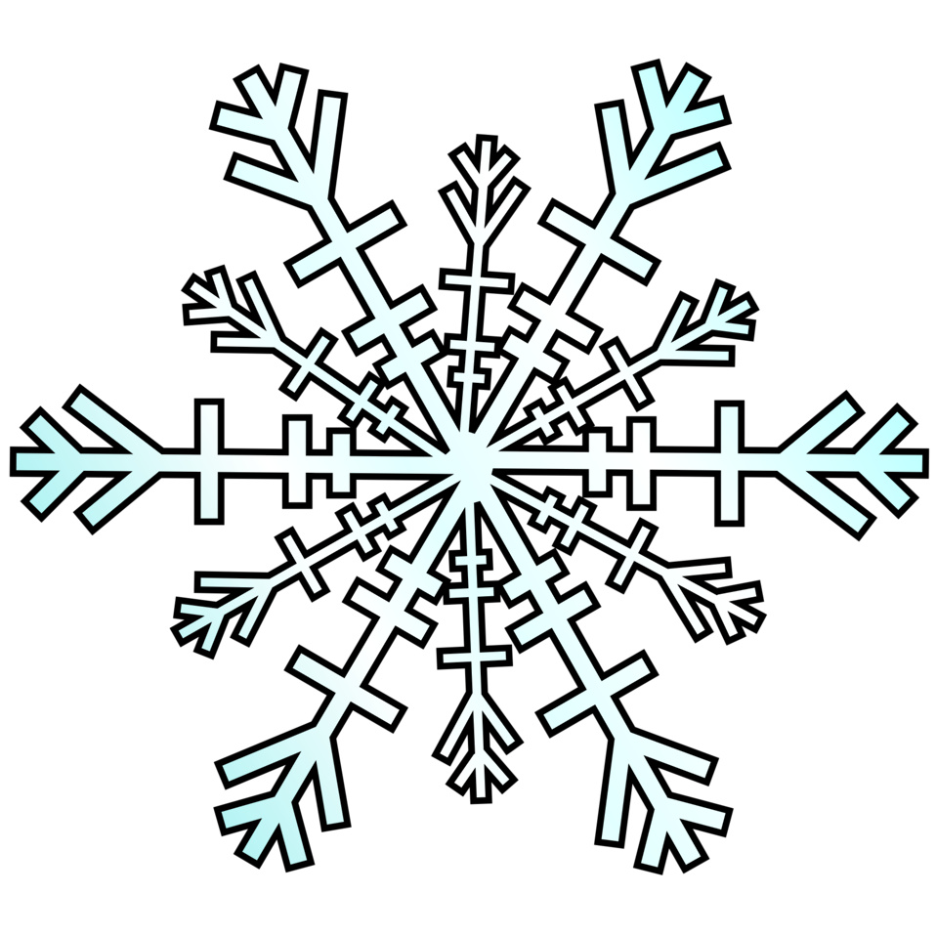

At Home Choice Board: Choose 2 activities to complete each school day!
Get a bowl of snow from outside (you can also use water or ice)! Use a magnifying glass, scoops, and spoons to observe, explore, and investigate! ASk and answer questions about snow! How does it feel, look, taste, sound, smell? | Create a snowflake using paper and scissors!  https://www.youtube.com/watch?v=oCuk8E-MhdE  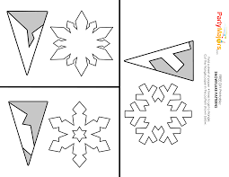 | Take a winter walk. Create a list of things you know about winter! What can you see, hear, smell, taste, and touch? | Use a magnifying glass to look at real snowflakes or see attached “Snowflake Study” sheet. Can you see 6 sides? Why do the snowflakes look so big? | Learn about the letters l, i, and u:  https://www.youtube.com/watch?v=hYqkCVqUHbk  https://www.youtube.com/watch?v=1ZEqHJUUyQk  https://www.youtube.com/watch?v=f4seEeExvVs
Use the snowflake patterns attached. Write one letter of your child’s name on each snowflake. Cut them out and have your child put the letters in the correct order!  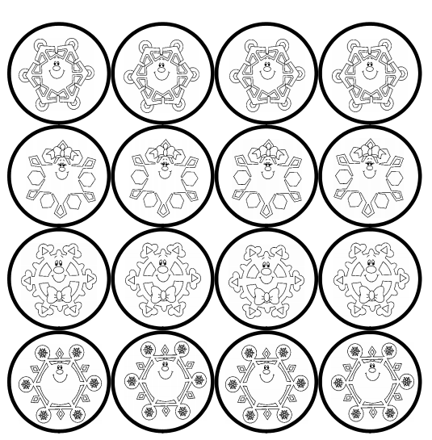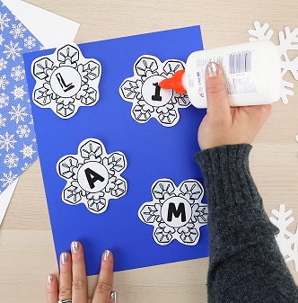 | Practice fine motor skills! Use a clothespin to grab a cotton ball and place it on a dish or cup! Count them as you go!  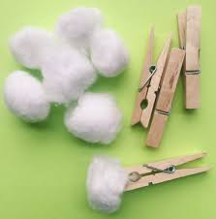 | Practice writing the letters l, i, and u (attached practice pages) | Learn about snowflakes: https://www.youtube.com/watch?v=-M48RfaWcWA Then, use blue, gray, and white paper scraps to cover the snowflake shape (attached).  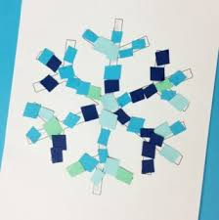 | Learn about icicles here: https://www.youtube.com/watch?v=eLBi0iCP1zg  Then practice scissor skills! Use a marker to draw zig zags across paper. Cut on the lines to make icicles!  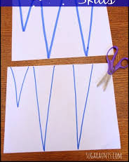
Practice counting to 8!  https://www.youtube.com/watch?v=n8COZPpQWgQ | Practice counting to 8 and make an octopus- count to 8 using cereal for counters on its tentacles (attached) | Practice counting to 8- use the nest worksheet (attached) and draw eggs and chicks!  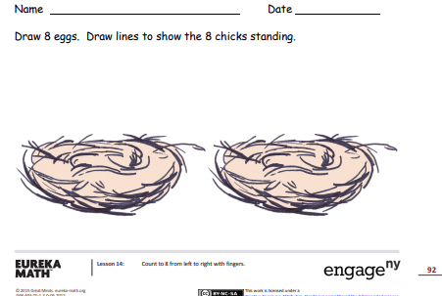 | Play a matching game with the snowflake cards (attached) | Practice counting to 8 using the Ansel Ant & Spencer Spider worksheet (attached). 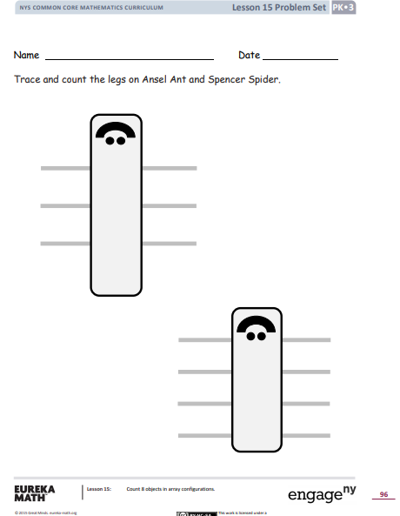
Unit: Let’s Investigate Winter
Theme: Winter Fun

Essential Question: How can I learn more about things?
Focus Questions: How can I learn by observing? How can I use tools to investigate? How do objects move?

Vocabulary: compare, observe, tools, senses, problem, solve, winter, snow, icicle, investigate, mystery,

Materials:
Paper, crayons, pencils, glue, scissors, marker
Hot Cocoa game (attached), mini marshmallows
Hot Chocolate Tasting (attached), hot cocoa packet and water
Snowball fight template (attached)
In Winter journal page (attached)
Snowman Game (attached)
Math worksheets #16 & 17 (attached)
Inside Snowmen (attached)
Letters t, f, e (attached)

Read Alouds to View:
Sadie and the Snowman by Allen Morgan https://www.youtube.com/watch?v=6lWTmSF_Ak4
Let it Snow by Maryann Cocca-Leffler https://www.youtube.com/watch?v=vIBYIRtIIfE
Snowballs by Lois Ehlert https://www.youtube.com/watch?v=-YT-VgNxv98
The Snowy Day by Ezra Jack Keats https://www.youtube.com/watch?v=FmZCQfeWjeQ
Snowmen at Night by Caralyn Buehner https://www.youtube.com/watch?v=61cTUGHHlCQ

Questions/Discussion Ideas after Read Alouds:
* What can you do in winter?
* What are things you can do inside and outside?
* What is your favorite thing to do?
* Review your child’s full name, age, birthday, and address!

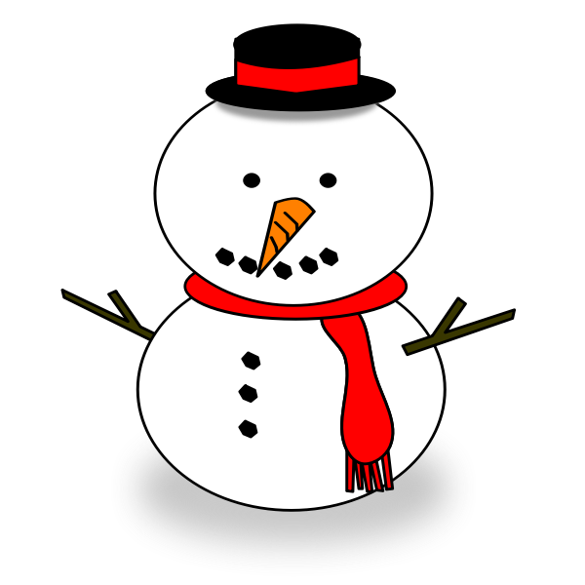

At Home Choice Board: Choose 2 activities to complete each school day!
Practice counting 8, then breaking 8 into smaller parts.  Use Math Worksheet #16 as a guide. | Play a snowman game. Hide a penny under one snowman. Tell your child to solve the mystery of which snowman has the penny. You give clues to them (under the snowman with no mittens, etc). | On a snowy day, make tracks in the snow. Walk with your feet in different patterns and directions. Talk about your tracks in comparison to your child’s . | Practice writing the letters t, f, and e- see attached practice pages.  AND:  Write your name. Use crayons in different shades of blue! | Learn about the letters t, e, and f  https://www.youtube.com/watch?v=nj2zXZAIsHk  https://www.youtube.com/watch?v=RiDUvOMm4pQ  https://www.youtube.com/watch?v=rOKQgYyIfv0
Build an indoor snowman (see attached for ideas if you need them)! | Practice counting:  https://www.youtube.com/watch?v=8qYj3Zh4PJA | Check out how some winter vehicles move:  https://www.youtube.com/watch?v=6SZwShdOGlU  https://www.youtube.com/watch?v=yPC-kdaqZwk  https://www.youtube.com/watch?v=5oa8P3HJhYw | Practice counting mini marshmallows. Count 8, break into smaller groups, then recount. Count in a circle as well. Extra practice is on Math Worksheet #17 | Review letters and sound with winter words::  https://www.youtube.com/watch?v=ljogrWPaKAo
Discuss what you can do in winter. Pick your favorite. Draw a picture of it on the In winter journal page. | Practice showing the numbers 6 & 7:  https://www.youtube.com/watch?v=anYJvL9kZoU  https://www.youtube.com/watch?v=PfEqSjgW4tk | Practice recognizing numerals and counting with the hot chocolate game (attached)  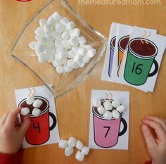 | Pretend you are a snowflake as you listen and dance:  https://www.youtube.com/watch?v=TDJIhayM9dw | Make hot chocolate. Talk about the tools you used to make it, and what it tastes, smells, feels, sounds, and looks like!  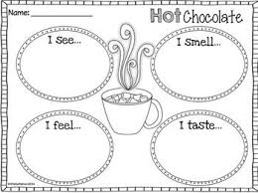
Unit: Let’s Investigate Winter
Theme: Winter Clothing

Essential Question: How can I learn more about things?
Focus Questions: How can I compare things?

Vocabulary: compare, observe, problem, solve, winter, snow, snowsuit, boots, mitten, scarf, investigate

Materials:
Paper, crayons, pencils, glue, scissors, markers
In winter, I wear... journal page (attached)
Math Lesson #24 worksheet (attached)
Clothing sort worksheets (attached)
Letters o, a , and d practice pages ((attached)
Hat template
Watercolor paints
Mitten game (attached)
Playdough
Hot/Cold worksheet (attached)

Read Alouds to View:
The Jacket I Wear in the Snow by Shirley Neitzel https://www.youtube.com/watch?v=mTYyPNPflBg
One Mitten by Kristine O’Connell George https://www.youtube.com/watch?v=_adc9ZCYKAs
Under my Hood, I Have a Hat by Karla Kuskin https://www.youtube.com/watch?v=KiOylehOQdQ

The Mitten by Jan Brett https://www.youtube.com/watch?v=uVdHH-hGBQw
Froggy Gets Dressed by Jonathon London https://www.youtube.com/watch?v=UveFBZ6Nn-c

Questions/Discussion Ideas after Read Alouds:
* What do people wear in the winter? Why?
* What would happen if we did not dress warmly?
* Who has the biggest boot in your house? The longest scarf?
* How does your hat feel? What does it look like?

At Home Choice Board: Choose 2 activities to complete each school day!
Learn about the letters o, a, and d:  https://www.youtube.com/watch?v=Xy7ALEnYsvE  https://www.youtube.com/watch?v=jPABwdH2Dqk  https://www.youtube.com/watch?v=VFOhxMZSMwc | Draw a picture of how you should dress in winter!  Use the In winter, I wear journal page. | Sort winter clothing using worksheets:  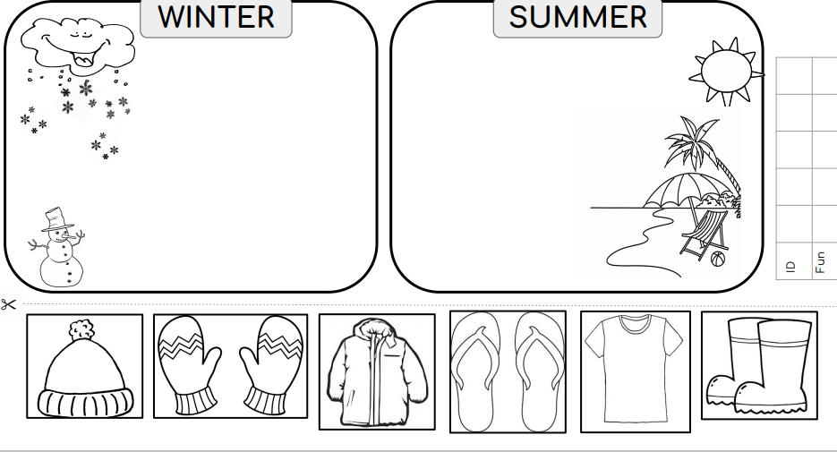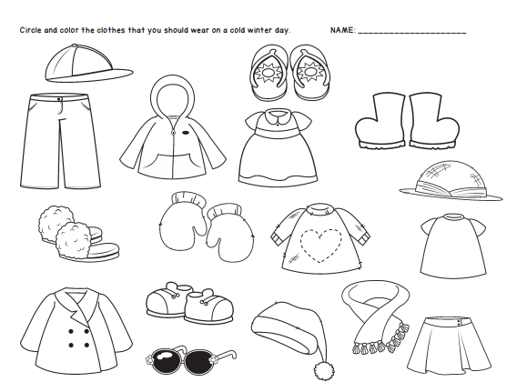 | Practice writing the letters o, a, and d- see attached practice pages | Sing about what to wear in the cold weather!  https://www.youtube.com/watch?v=CULyz139rIk
Practice getting dressed to play in the snow. Let your child try to zip, snap, put on everything! | Make a hat. (see attached)  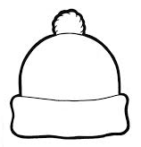 | Practice naming numerals and counting in the mutton game (attached): | Practice writing your name in shaving cream. Spray a small amount on a plate and have child write their names in it!  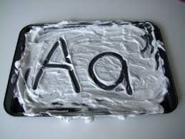 | Bring a bucket of snow in (or play outside). Try using different gloves or mittens, Compare them- which kept your hands warmest?
Enjoy some dressing songs & stories:  https://www.youtube.com/watch?v=_8RsrLQ3NhQ | Review colors with this story:  https://www.youtube.com/watch?v=jI-5-p5N38c | Review hot/cold with the attached sheet:  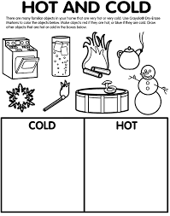 | Complete Math Lesson 24 worksheet.  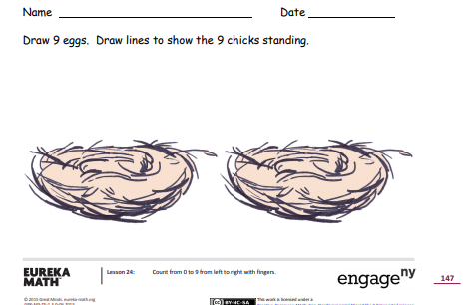 | Use the attached pictures to help retell the story of The Mitten. Talk about big/small, order animals by size.

Unit: Let’s Investigate Winter
Theme: What do animals do during the winter?
Essential Question: How can I learn more about things?
Focus Questions: How can I learn by observing? How can I compare things?

Vocabulary: compare, observe, hibernate, migrate, den, winter, snow, investigate,

Materials:
Paper, crayons, pencils, glue, scissors, markers
Animals in Winter journal page (attached)
Math Lessons #26 & 27 worksheets (attached)
Letters q, c, and s practice pages (attached)
Empty toilet paper tube
Bird seed
Peanut butter
String
Animals in Winter animal picture cards (attached)

Read Alouds to View:

Snack, Snooze and Skedaddle by Laura Purdie Salars https://www.youtube.com/watch?v=vfDjceTbuE4
Don’t Wake the Bear by Marjorie Denniw Murray https://www.youtube.com/watch?v=5q-ReCPd-RE
Time to Sleep by Denise Fleming https://www.youtube.com/watch?v=LFmhMt7JDZ0
Why Do Animals Hibernate? by David Martin https://www.youtube.com/watch?v=AHclJXhj6DQ

All About Animals in Winter by Martha E. H. Rustad https://www.youtube.com/watch?v=59Zau1gMahA

Questions/Discussion Ideas after Read Alouds:
* How do you stay warm when it gets cold and snows?
*How do you think animals stay safe in winter? After reading, did you learn anything?
*Would you rather hibernate, adapt, or migrate if you were an animal? Why?
*Pick two animals that spend winter in similar ways. How are they the same? How are they different?

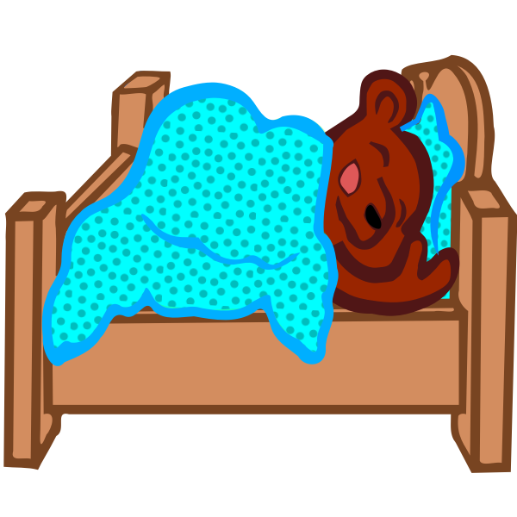

At Home Choice Board: Choose 2 activities to complete each school day!
Practice writing the letters q, c, and s- see attached practice pages | Learn about the letters q, c, and s:  https://www.youtube.com/watch?v=m6NkGVfj_L8  https://www.youtube.com/watch?v=8uLPe4tAkbk  https://www.youtube.com/watch?v=Dyf1nG78tDg | Practice counting with the worksheets #26 (attached) | Learn about animals in winter  https://www.youtube.com/watch?v=0N7FGPeykfE  https://www.youtube.com/watch?v=HRipSQPgzuw | Use playdough and form the letters in your name!
Get moving with this fun song:  https://www.youtube.com/watch?v=uBYNtMyN_6E | Build a blanket fort and pretend it is a den and you are hibernating bears! | Learn about animals on winter with the song:  https://www.youtube.com/watch?v=tIKOFNCkxmQ | Make an easy bird feeder! Tie string to an empty toilet paper tube, spread peanut butter on it, then roll in bird seed!  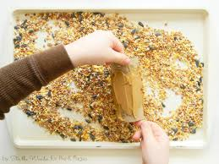 | Practice counting in circular arrangements with the worksheet #27 (attached)  https://www.youtube.com/watch?v=DR-cfDsHCGA
Use the attached Animals in Winter animal cards to sort animals that hibernate, migrate, or adapt in winter! | Roll a die. Have your child identify how many dots are shown. Have them complete a movement for the amount (4 push ups, 3 sit ups, etc) | Practice stating personal information (full name, address, birthday, caregiver name(s), phone number). | Review shapes and colors with a game of “I Spy.” | Draw a picture of animals in winter and state what they do to keep safe (attached).

MY COMMUNITY READING LOG
Read a story EVERY DAY!! Draw a star or smiley face or place a sticker on the date when done!
January
 |  |  |  |  | 1 | 2
3 | 4 | 5 | 6 | 7 | 8 | 9
10 | 11 | 12 | 13 | 14 | 15 | 16
17 | 18 | 19 | 20 | 21 | 22 | 23
24 | 25 | 26 | 27 | 28 | 29 | 30
31

Math Lessons:
***Click on the links below to see full lessons and activities to support the skills.**

Week 1:
https://www.engageny.org/resource/prekindergarten-mathematics-module-3-topic-c-lesson-12
https://www.engageny.org/resource/prekindergarten-mathematics-module-3-topic-c-lesson-13
https://www.engageny.org/resource/prekindergarten-mathematics-module-3-topic-c-lesson-14
https://www.engageny.org/resource/prekindergarten-mathematics-module-3-topic-c-lesson-15

Week 2:
https://www.engageny.org/resource/prekindergarten-mathematics-module-3-topic-d-lesson-16
https://www.engageny.org/resource/prekindergarten-mathematics-module-3-topic-d-lesson-17
https://www.engageny.org/resource/prekindergarten-mathematics-module-3-topic-d-lesson-18
https://www.engageny.org/resource/prekindergarten-mathematics-module-3-topic-d-lesson-19
https://www.engageny.org/resource/prekindergarten-mathematics-module-3-topic-d-lesson-20

Week 3:
https://www.engageny.org/resource/prekindergarten-mathematics-module-3-topic-e-lesson-21
https://www.engageny.org/resource/prekindergarten-mathematics-module-3-topic-e-lesson-22
https://www.engageny.org/resource/prekindergarten-mathematics-module-3-topic-e-lesson-23
https://www.engageny.org/resource/prekindergarten-mathematics-module-3-topic-e-lesson-24
https://www.engageny.org/resource/prekindergarten-mathematics-module-3-topic-e-lesson-25

Week 4:
https://www.engageny.org/resource/prekindergarten-mathematics-module-3-topic-f-lesson-26
https://www.engageny.org/resource/prekindergarten-mathematics-module-3-topic-f-lesson-27
https://www.engageny.org/resource/prekindergarten-mathematics-module-3-topic-f-lesson-28
https://www.engageny.org/resource/prekindergarten-mathematics-module-3-topic-f-lesson-29
https://www.engageny.org/resource/prekindergarten-mathematics-module-3-topic-f-lesson-30

